Ranking
Assign a rank to products within each category based on price (highest price = Rank 1)

SELECT product_id, product_name,price,RANK() OVER (ORDER BY price DESC) AS price_rank FROM products;

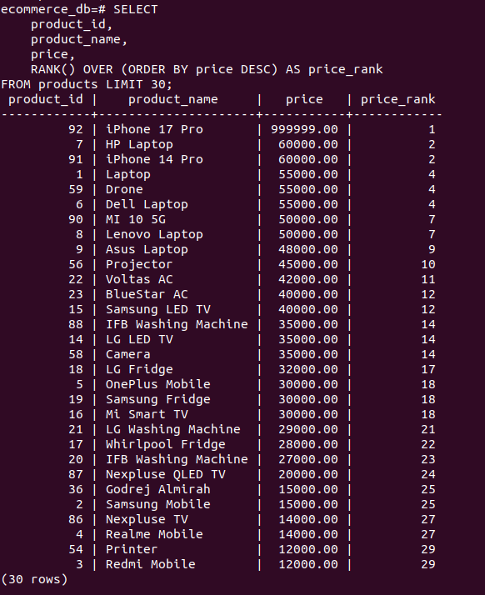

Explanation:
- This query ranks all products based on their price using the RANK() window function.
- The most expensive product receives Rank 1, allowing easy comparison of product prices across the store.

Running Total
Calculate the cumulative sum of product prices ordered by product ID

SELECT product_id,product_name,price, SUM(price) OVER (ORDER BY product_id) AS running_total FROM products;
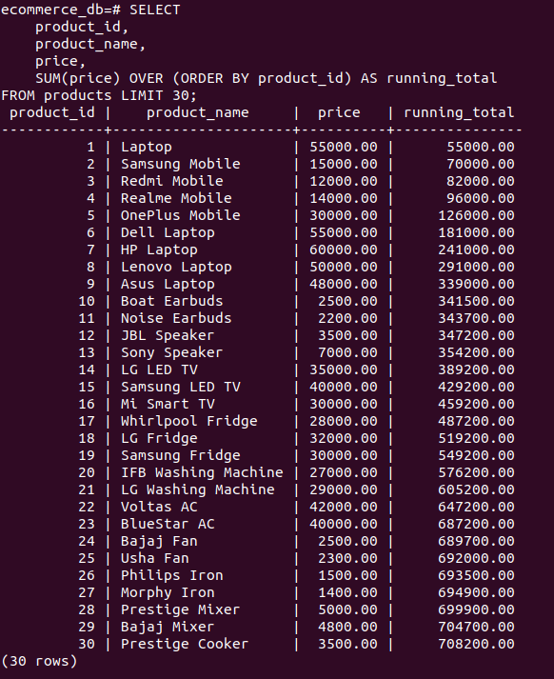

Explanation:
- This query calculates a running total of product prices. As product IDs increase, prices are added cumulatively, which helps track the total value of products step by step.

Lead Function
Display each product’s price along with the price of the next most expensive product

SELECT product_id,product_name,price,LEAD(price) OVER (ORDER BY price DESC) AS next_expensive_price FROM products;

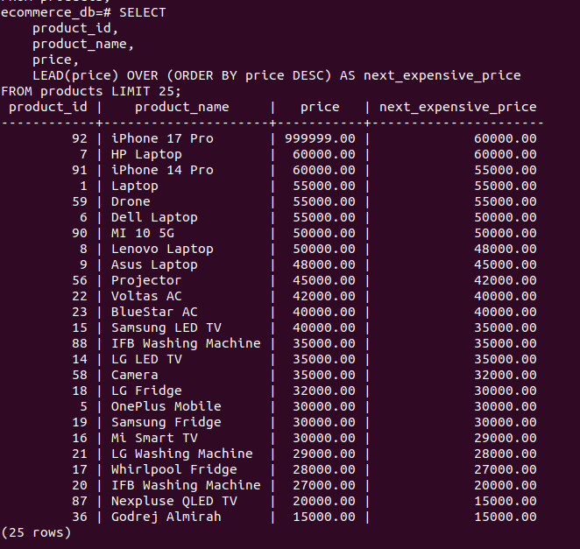

Explanation:
- The LEAD() function shows the price of the next most expensive product when products are ordered by price in descending order. This is useful for comparing price gaps between products.

